MULTILINGUAL ACCESSIBILITY OF WEB IMAGES FOR PERSONS WITH VISUAL IMPAIRMENTS USNG STEGANOGRAPHY (product)

Submitted by

KATHIRVEL K
(Register No. 20394011)

Under the guidance of

Dr K S KUPPUSAMY

Project phase 2 report submitted for the degree of

MASTER OF TECHNOLOGY

IN

NETWORK AND INFORMATION SECURITY



DEPARTMENT OF COMPUTER SCIENCE
SCHOOL OF ENGINEERING AND TECHNOLOGY
PONDICHERRY UNIVERSITY
PUDUCHERRY 605014
MAY 2022

MULTILINGUAL ACCESSIBILITY OF WEB IMAGES FOR PERSONS WITH VISUAL IMPAIRMENTS USNG STEGANOGRAPHY (product)

Submitted by

KATHIRVEL K
(Register No. 20394011)

Under the guidance of

Dr K S KUPPUSAMY

Project phase 2 report submitted for the degree of

MASTER OF TECHNOLOGY

IN

NETWORK AND INFORMATION SECURITY



DEPARTMENT OF COMPUTER SCIENCE
SCHOOL OF ENGINEERING AND TECHNOLOGY
PONDICHERRY UNIVERSITY
PUDUCHERRY 605014
MAY 2022

DEPARTMENT OF COMPUTER SCIENCE
SCHOOL OF ENGINEERING AND TECHNOLOGY
PONDICHERRY UNIVERSITY


CERTIFICATE

This is to certify that the project work entitled “MULTILINGUAL ACCESSIBILITY OF WEB IMAGES FOR PERSONS WITH VISUAL IMPAIRMENTS USNG STEGANOGRAPHY” is a genuine and original research work carried out by Mr KATHIRVEL K (Reg. No. 20394011) - MASTER OF TECHNOLOGY in NETWORK AND INFORMATION SECURITY of Pondicherry University, Puducherry under my guidance and supervision. The thesis work is not submitted earlier for the award of any degree/diploma or associateship of any other University / Institution.

DATE: 25 May 2022 PROJECT GUIDE
( Dr. K S KUPPUSAMY)

DEPARTMENT OF COMPUTER SCIENCE
SCHOOL OF ENGINEERING AND TECHNOLOGY
PONDICHERRY UNIVERSITY


BONAFIDE CERTIFICATE

This is to certify that the Project Work titled “MULTILINGUAL ACCESSIBILITY OF WEB IMAGES FOR PERSONS WITH VISUAL IMPAIRMENTS USNG STEGANOGRAPHY” is a bonafide work of Mr KATHIRVEL K (Reg. No. 20394011) Carried out in PROJECT PHASE 2 for the award of the degree of MASTER OF TECHNOLOGY in NETWORK AND INFORMATION SECURITY of Pondicherry University, Puducherry under my guidance. This project work is original and not submitted earlier for the award of any degree/diploma or associateship of any other University / Institution.

HEAD OF THE DEPARTMENT PROJECT GUIDE
(Dr. S SIVA SATHYA) (Dr. K S KUPPUSAMY )

Submitted for the University Examination held on

INTERNAL EXAMINER EXTERNAL EXAMINER

TABLE OF CONTENTS

Sl. No | Contents | Page
 | Base Paper | 1-13
 | Problem Definition | 14-15
 | Architecture Diagram | 16
 | Design | 17-18
 | Background Study | 19-20
 | Coding | 21-31
 | Inputs | 32-33
 | Outputs | 34-36
 | Analysis | 37
 | Conclusion | 38
 | Future Enhancement | 39
 | References | 40-41

CHAPTER 2
ABSTRACT

In today’s modern world, user interfaces are built-in a way that attracts people to use with the help of various multimedia content like images, videos, graphs, charts etc., Especially images are the prominent content of the webpage since the human brain understands the information in pictorial form faster than in textual form. Screen readers are the special software designed to assist visually impaired persons to consume digital content with the help of audio. These screen readers are capable of reading the textual content on the screen, but multimedia content present on the webpage can’t be read by screen readers. In that case, alt attributes/filename of images are read by most of the screen readers. But the majority of websites don’t have proper alternative text. Even though W3C recommend the usage of alternative text to all multimedia files to make them accessible to assistive technology as well, developers find it is the time-consuming and repetitive task of giving alternative text to all instance of the same/different image used throughout the website. It can be solved by implementing a model that predicts the image’s content using Machine learning. These predicted keywords are embedded into the images using steganography methods. Later These descriptions are extracted, translated and updated in the alt attribute by the browser extension which can be easily read by the screen readers on the client-side. Multilingual alt text updation is achieved based on the user’s preference via the translator module in the extension. Thereby this AIMS design improves the usability for visually impaired users.

PROBLEM DEFINITION

A screen reader is a software application that reads the on-screen information and uses its text-to-speech (TTS) engine to translate it into speech or refreshable Braille. Screen reader increases the independence of visually impaired persons in accessing computing devices. These screen readers are often used by visually impaired people to access web content. Information in pictorial or graphical representations are easily conveyed to users than in textual form, so websites are developed with text, images, videos and other graphical content. But screen readers are only capable of reading the textual contents of the webpage. Important information in the form of images like pie charts, graphs etc., can be skipped by these screen readers. In this case, the alternative text given to the image can be read by screen readers. If the alt attribute is not given to the image, the file name can be read by screen readers that are often not meaningful/relevant. The existing design proposed by Ab Shaqoor Nengroo, and K. S. Kuppusamy [2018] on making self‑describing images to assist screen readers fixes this problem by hiding the image description in the image which can be decoded by the browser extension on the client-side and updated in the alt attribute of the image tag. Even though this helps screen readers, but increases the work of Webmasters where they manually have to embed the appropriate alternative text in each image which is found to be a time-consuming and recurring task. And this also lacks the multilingual alt text updation based on the website’s native language/user preferred language choice.

CHAPTER 3
ARCHITECTURE DIAGRAM
The existing AIMS architecture consists of two primary models which are given in detail below
- AIMS builder
- AIMS browser extension
AIMS Builder
AIMS builder helps in embedding images behind the image without reducing much of its quality using steganography methods. It can be done by LSB (Least significant bit) technique which is simple, fast and carries high payloads. LSB works by replacing the right-most bit, i.e., the least significant bit (LSB) position of randomly selected pixels within the carrier image by the message bits. LSB can store a good amount of text in informative and functional images as these images usually have proper dimensions and quality for a better visual appearance of a web page.
AIMS Browser Extension
AIMS extension is a browser extension which is installed as an add-on to the browser. It extracts the message embedded in the image by finding the image tag on the source code of the webpage. The extracted message is updated on the alt attribute of the respective <img> tags which can be easily read by the screen readers.
The overall existing architecture of the AIMS system is given in figure 1.
Figure 1 – Overall architecture
CHAPTER 4
DESIGN

AIMS Builder
- AIMS builder is the web application which gets the image as the input from the user and sends the data to the python flask server.
- Flask server performs object detection and returns the detected objects.
- Input image and detected objects are embedded into the image using the LSB steganography algorithm.



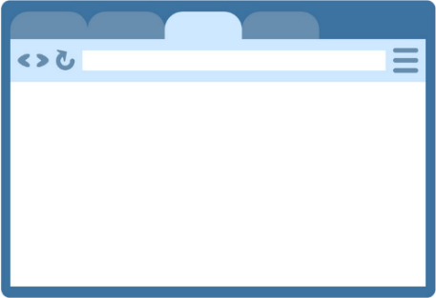

Developer
Carrier Image
Detected Objects
Annotated Image

AIMS Builder
Detected Objects

Flask Server
Figure 2 – AIMS builder architecture

- Then finally we got the annotated image as the output which can be downloaded and used on web pages.

AIMS Extension

- AIMS browser extension mail functionality is to extract the embedded message from the image.
- AIMS extension also gets the user preferred language as input and translates the extracted message as per the user preferences.
- The detailed flow of the AIMS browser extension is given as below.







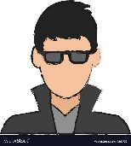

VI User
Flask Server
5
2
1
4
3
AIMS Extension
------------------------------------------------------------------------------------------------------------------------------------
--------------------------------------------------------------------------------------------------------------------------------------------------------------------------------------------------------------------------------------------------------------------------------------------------------------
-------------------------------------------------------------------------------------------------------------------------------------------------------------------------------------------------------------------------------------------------------------------------------------------------------------
Figure 3 – AIMS extension architecture

1 - VI user surfs the websites
2 - Image src is passed to extension as input
3 - The embedded message is decoded from the image and the language user chosen is sent to the flask server
4 - The flask server translates the embedded message as per the user preference and returns the result to the extension.
5 - Extension set alt attribute to the image tags

CHAPTER 5
BACKGROUND STUDY

Least Significant Bit (LSB)
The entire AIMS design is based on image steganography. Steganography is the technique of hiding a secret message by embedding it into a file. In AIMS, the Least Significant Bit (LSB) technique is used to embed and extract the alternative text on the image. LSB works by replacing the right-most bit, i.e., the least significant bit (LSB) position of randomly selected pixels within the carrier image by the message bits. The embedding operation of LSB is given by the below equation,
y_{i} = [ x_{i} / 2 ] + m_{i}
where, m_{i} = ith Message bit
x_{i} = ith selected pixel value before embedding
y_{i} = ith selected pixel value after embedding

Embedding Algorithm for LSB | Extraction algorithm for LSB
procedure LSBWrite(carrier img,alt text)  C carrier img, M alt text  for i = 1 to len(M) do  Compute ij of Cij pixel to store ith bit of M  p LSB bit of Cij pixel  if p! = Mi then  Cij Mi //Store message bit in LSB  return annotated image | procedure LSBRead(carrier img)  for i = 1 to len(M) do  Compute ij where Mi is stored  Mi Cij //Get message bit from LSB  return alt text

Browser extension
Another important component of the AIMS system is the chrome browser extension. Extensions are added to the browser as an addon. Extension components are created with web development technologies like HTML, CSS, and JavaScript. Extensions include manifest, content scripts, background scripts and UI elements.

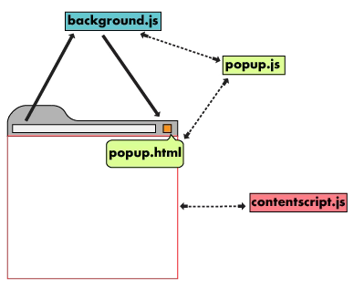
Manifest file - Every extension must have JSON-formatted manifest file, named manifest.json, that provides important information like manifest version, name, icon, permission, included scripts, action etc.,
Background scripts - The background script is a script running in the background to handle the majority of chrome events that content scripts cannot. Unlike content scripts, the background script runs in the browser level context.
Content scripts - Content scripts are script files that run in the context of web pages.
UI elements – The user interface of the chrome extension is created in HTML and CSS which gets loaded when the user clicks on the extension.
Figure 4 – Chrome extension components

ImageAI library
ImageAI is a python library built by the DeepQuest AI team to empower developers, researchers and students to build applications and systems with self-contained Deep Learning and Computer Vision capabilities.
With the Image AI library, anyone can easily perform custom image prediction, object detection, video detection and video object tracking with fewer lines of code.

CHAPTER 6
CODE

AIMS Builder
App.py
Initializing the variables
UPLOAD_FOLDER = 'static\\files'
ALLOWED_EXTENSIONS = {'JPG', 'JPEG', 'PNG', 'jpg', 'jpeg', 'png'}

Configuring the Flask application
app = Flask(__name__)
app.config['UPLOAD_FOLDER'] = UPLOAD_FOLDER

Check file extension – validate whether the uploaded files are images. Support JPG, JPEG and PNG file formats
def allowed_file(filename):
return '.' in filename and \
filename.rsplit('.', 1)[1].lower() in ALLOWED_EXTENSIONS

Routing the path to index.html
@app.route("/")
def index():
return render_template("/index.html")

Routing the path to uploader.html
@app.route('/uploader', methods = ['GET', 'POST'])
def upload_file():
result=""
imagename=""
image_name=""
detectedobjects=''
finaldetectedobjects=''
if request.method == 'POST':
file = request.files['pic']
message=''
if file.filename == '':
message="Please select a file"
flash(message,'error')
elif not allowed_file(file.filename):
message="Only images files are allowed"
flash(message, 'error')
else :
file.save(os.path.join(app.config['UPLOAD_FOLDER'],'image.jpg'))
message="File uploaded and analysed successfully"
image_name = "static/files/image.jpg"
flash(message, 'result')
finaldetectedobjects=objdetection.detectobj()
print(finaldetectedobjects)
return render_template('upload.html', imagename=image_name, result=finaldetectedobjects)

Driver code
if __name__ == "__main__":
app.run(
debug='true',
threaded=False
)

index.html
File upload form – gets the file uploaded and saves it in the server
<form action = "http://localhost:5000/uploader" method = "POST"
enctype = "multipart/form-data">
<input
class="ui primary button"
type="file"
name="pic"
accept="image/*"
onchange="readURL(this);"/>
<button class="ui secondary button" name="btn" value="upload" style="height: 42px;"> Analyse </button>
</form>

Exception handling - Throw the error message to the user
{% for mesg in get_flashed_messages() %}
<p class="errormsg">{{ mesg }}</p>
{% endfor %}

uploader.html
Update the image and result to the user
<img id="image1" src="{{imagename}}" alt="" />

<h5 id="result_text">{{result}}</h5>

Message extraction – extract the embedded message from the image
</form>
<button id="hidetext_button" class="ui secondary button" onclick="hideText()">
Hide Message Into Image
</button>

index.js
Get the uploaded image URI
var imgdatauri;
function readURL(input) {
if (input.files && input.files[0]) {
var reader = new FileReader();
reader.onload = function(e) {
document.querySelector("#image1").src = e.target.result;
imgdatauri = e.target.result;
};
}
reader.readAsDataURL(input.files[0]);
}

Embed the message into the carrier image
function hideText() {
document.querySelector("#image2").src = steg.encode(document.querySelector('#result_text').innerHTML, 'http://localhost:5000/static/files/image.jpg');
}

Extract the embedded message from image
function decode(input) {
if (input.files && input.files[0]) {
var reader = new FileReader();
reader.onload = function(e) {
console.log(steg.decode(e.target.result));
document.querySelector('#decoded').innerText = steg.decode(e.target.result);
};
}
reader.readAsDataURL(input.files[0]);
}

objdetection.py
Perform object detection to the uploaded image and return the result
def detectobj():
allObjects =[]
execution_path = os.getcwd()
detector = ObjectDetection()
detector.setModelTypeAsRetinaNet()
detector.setModelPath( os.path.join(execution_path , "resnet50_coco_best_v2.0.1.h5"))
detector.loadModel()
detections = detector.detectObjectsFromImage(input_image=os.path.join(execution_path , "C:\\Users\\kathi\\PycharmProjects\\AIMS\\venv\\static\\files\\image.jpg"), output_image_path=os.path.join(execution_path , "C:\\Users\\kathi\\PycharmProjects\\AIMS\\venv\\static\\files\\detectedobj\\imagenew.jpg"))
for eachObject in detections:
allObjects.append(eachObject["name"])
allObjectslist= list(dict.fromkeys(allObjects))
values = {"value": "This image contains " +' '.join(allObjectslist)}
return values['value']

steganography.js
Performs embedding and extraction of image description on the input image using the steganography algorithm [Developed by Peter Eigenschink]
! function(a, b, c) {
"undefined" != typeof module && module.exports ? module.exports = c() : "function" == typeof define && define.amd ? define(c) : b[a] = c()
}("steg", this, function() {
var a = function() {},
b = {
isPrime: function(a) {
if (isNaN(a) || !isFinite(a) || a % 1 || 2 > a) return !1;
if (a % 2 === 0) return 2 === a;
if (a % 3 === 0) return 3 === a;
for (var b = Math.sqrt(a), c = 5; b >= c; c += 6) {
if (a % c === 0) return !1;
if (a % (c + 2) === 0) return !1
}
return !0
},
findNextPrime: function(a) {
for (var c = a; !0; c += 1)
if (b.isPrime(c)) return c
},
sum: function(a, b, c) {
var d = 0;
c = c || {};
for (var e = c.start || 0; b > e; e += c.inc || 1) d += a(e) || 0;
return 0 === d && c.defValue ? c.defValue : d
},
product: function(a, b, c) {
var d = 1;
c = c || {};
for (var e = c.start || 0; b > e; e += c.inc || 1) d *= a(e) || 1;
return 1 === d && c.defValue ? c.defValue : d
},
createArrayFromArgs: function(a, b, c) {
for (var d = new Array(c - 1), e = 0; c > e; e += 1) d[e] = a(e >= b ? e + 1 : e);
return d
},
loadImg: function(a) {
var b = new Image;
return b.src = a, b
}
};
return a.prototype.config = {
t: 3,
threshold: 1,
codeUnitSize: 16,
args: function(a) {
return a + 1
},
messageDelimiter: function(a, b) {
for (var c = new Array(3 * b), d = 0; d < c.length; d += 1) c[d] = 255;
return c
},
messageCompleted: function(a, b, c) {
for (var d = !0, e = 0; 16 > e && d; e += 1) d = d && 255 === a[b + 4 * e];
return d
}
}, a.prototype.getHidingCapacity = function(a, b) {
b = b || {};
var c = this.config,
d = b.width || a.width,
e = b.height || a.height,
f = b.t || c.t,
g = b.codeUnitSize || c.codeUnitSize;
return f * d * e / g >> 0
}, a.prototype.encode = function(a, c, d) {
if (c.length) c = b.loadImg(c);
else if (c.src) c = b.loadImg(c.src);
else if (!(c instanceof HTMLImageElement)) throw new Error("IllegalInput: The input image is neither an URL string nor an image.");
d = d || {};
var e = this.config,
f = d.t || e.t,
g = d.threshold || e.threshold,
h = d.codeUnitSize || e.codeUnitSize,
i = b.findNextPrime(Math.pow(2, f)),
j = d.args || e.args,
k = d.messageDelimiter || e.messageDelimiter;
if (!f || 1 > f || f > 7) throw new Error('IllegalOptions: Parameter t = " + t + " is not valid: 0 < t < 8');
var l = document.createElement("canvas"),
m = l.getContext("2d");
l.style.display = "none", l.width = d.width || c.width, l.height = d.height || c.height, d.height && d.width ? m.drawImage(c, 0, 0, d.width, d.height) : m.drawImage(c, 0, 0);
var n, o, p, q, r, s, t, u, v, w, x = m.getImageData(0, 0, l.width, l.height),
y = x.data,
z = h / f >> 0,
A = h % f,
B = [];
for (v = 0; v <= a.length; v += 1) {
if (s = a.charCodeAt(v) || 0, t = A * v % f, t > 0 && o) {
if (u = Math.pow(2, f - t) - 1, p = Math.pow(2, h) * (1 - Math.pow(2, -t)), q = (s & u) << t, r = (o & p) >> h - t, B.push(q + r), v < a.length) {
for (u = Math.pow(2, 2 * f - t) * (1 - Math.pow(2, -f)), w = 1; z > w; w += 1) n = s & u, B.push(n >> (w - 1) * f + (f - t)), u <<= f;
A * (v + 1) % f === 0 ? (u = Math.pow(2, h) * (1 - Math.pow(2, -f)), n = s & u, B.push(n >> h - f)) : f >= A * (v + 1) % f + (f - t) && (n = s & u, B.push(n >> (z - 1) * f + (f - t)))
}
} else if (v < a.length)
for (u = Math.pow(2, f) - 1, w = 0; z > w; w += 1) n = s & u, B.push(n >> w * f), u <<= f;
o = s
}
var C, D, E, F, G, H = k(B, g);
for (C = 0; 4 * (C + g) <= y.length && C + g <= B.length; C += g) {
for (G = [], v = 0; g > v && v + C < B.length; v += 1) {
for (F = 0, w = C; g + C > w && w < B.length; w += 1) F += B[w] * Math.pow(j(v), w - C);
G[v] = 255 - i + 1 + F % i
}
for (v = 4 * C; v < 4 * (C + G.length) && v < y.length; v += 4) y[v + 3] = G[v / 4 % g];
E = G.length
}
for (D = C + E; D - (C + E) < H.length && 4 * (C + H.length) < y.length; D += 1) y[4 * D + 3] = H[D - (C + E)];
for (v = 4 * (D + 1) + 3; v < y.length; v += 4) y[v] = 255;
return x.data = y, m.putImageData(x, 0, 0), l.toDataURL()
}, a.prototype.decode = function(a, c) {
if (a.length) a = b.loadImg(a);
else if (a.src) a = b.loadImg(a.src);
else if (!(a instanceof HTMLImageElement)) throw new Error("IllegalInput: The input image is neither an URL string nor an image.");
c = c || {};
var d = this.config,
e = c.t || d.t,
f = c.threshold || d.threshold,
g = c.codeUnitSize || d.codeUnitSize,
h = b.findNextPrime(Math.pow(2, e)),
i = (c.args || d.args, c.messageCompleted || d.messageCompleted);
if (!e || 1 > e || e > 7) throw new Error('IllegalOptions: Parameter t = " + t + " is not valid: 0 < t < 8');
var j = document.createElement("canvas"),
k = j.getContext("2d");
j.style.display = "none", j.width = c.width || a.width, j.height = c.width || a.height, c.height && c.width ? k.drawImage(a, 0, 0, c.width, c.height) : k.drawImage(a, 0, 0);
var l, m, n = k.getImageData(0, 0, j.width, j.height),
o = n.data,
p = [];
if (1 === f)
for (l = 3, m = !1; !m && l < o.length && !m; l += 4) m = i(o, l, f), m || p.push(o[l] - (255 - h + 1));
var q = "",
r = 0,
s = 0,
t = Math.pow(2, g) - 1;
for (l = 0; l < p.length; l += 1) r += p[l] << s, s += e, s >= g && (q += String.fromCharCode(r & t), s %= g, r = p[l] >> e - s);
return 0 !== r && (q += String.fromCharCode(r & t)), q
}, new a
});

AIMS Extension
manifest.json
{
"description": "This extension will provide alternate text for images.",
"manifest_version":2,
"name": "AIMS extension",
"version": "3",
"icons": {
"48": "icons/icon.png"},
"content_scripts":[
{
"matches":["<all_urls>"],
"js":["content.js"]
}
],
"background":{
"scripts":["background.js"]
},
"browser_action": {
"default_popup": "popup.html",
"default_title": "Accessible Images"
},
"permissions": ["tabs","downloads","activeTab","contextMenus"]
}

popup.html
Getting the languages as the input from the user
<script type="text/javascript" src="steganography.js"></script>
<form name="language_form">
Language
<select id="language_select" name="language">
<option value="en">English</option>
<option value="ta">Tamil</option>
<option value="fr">French</option>
<option value="hi">Hindi</option>
<option value="ka">Kanada</option>
<option value="te">Telugu</option>
</select><br><br>
<input type="button" id="setlang" value="Set">
</form>
<script type="text/javascript" src="popup.js"></script>

popup.js
Get the language selected by the user in select box and store it in local storage
document.getElementById('language_select').value=localStorage.getItem('selected_value')
const btn = document.getElementById("setlang");
btn.addEventListener('click', ()=>{
console.log("button clicked");
let queryoptions = {active:true, currentWindow: true };
chrome.tabs.query(queryoptions, (tabs)=>{
console.log(tabs[0].id);
var lang = document.querySelector('#language_select').value;
console.log(lang);
localStorage.setItem("selected_value",lang);
var svalue = localStorage.getItem('selected_value');
console.log("lang "+svalue);
let language = {
a: svalue
};
chrome.tabs.query({active: true, currentWindow: true}, function(tabs) {
chrome.tabs.sendMessage(tabs[0].id, language, function(response) {
console.log(response);
});
});
});
});

Get the language stored in local storage
var svalue = localStorage.getItem('selected_value');
console.log("lang "+svalue);
let language = {
a: svalue
};

Pass the value to content scripts
chrome.tabs.query({active: true, currentWindow: true}, function(tabs) {
chrome.tabs.sendMessage(tabs[0].id, language, function(response) {
console.log(response);
});
});

content.js
Get the message from popup scripts
chrome.runtime.onMessage.addListener(receiver);
function receiver(request, sender, sendResponse){
const lang = request.a;
localStorage.setItem("langvalue",lang);
}

Get the image tag present on the website
var images = document.getElementsByTagName('img');
for(var i = 0; i < images.length; i++)
{
if(images[i].alt===""||images[i].alt==='null')
{
imgurl=images[i].src;
console.log(imgurl);
msg=steg.decode(imgurl);
console.log(msg);
x = localStorage.getItem("langvalue");
let obj = {
b: x,
c: msg,
d: imgurl
};
dotranslate(obj);
}
}

Perform translation for the image description
function dotranslate(obj){
fetch('http://localhost:5001/dotranslate',{
method: "POST",
body: JSON.stringify(obj),
cache:"no-cache",
headers: new Headers({
"content-type": "application/json"
})
})
.then(function(response){
if(response.status !== 200){
console.log(`Response status was not 200: ${response.status}`);
return ;
}
response.json().then(function (data){
for(var i = 0; i < images.length; i++)
{
alter.push(images[i].src)
}
for(var i=0; i < images.length; i++)
{
if (alter[i] == Object.keys(data)){
images[i].setAttribute('alt', data[Object.keys(data)] );
}
}
})
})
}

app.py
Configuring the flask application
app = Flask(__name__)
CORS(app)
PORT = 5001

Routing the path to dotranslate
dotranslate function translates the image description using python google trans module
@app.route('/dotranslate', methods=['GET', 'POST'])
def dotranslate():
a = 'key'
data = request.get_json()
language = data['b']
objects = data['c']
imageurl = data['d']
print("lang : "+ language +" obj : "+objects+ " imgurl : "+imageurl)
translator = Translator()
trans = translator.translate(objects, dest=language)
print(trans)
return {imageurl : trans.text}

Driver code
if __name__ == "__main__":
app.run(
host='0.0.0.0',
port=PORT,
debug=True,
threaded=True
)

CHAPTER 7
INPUTS
AIMS BUILDER
- AIMS builder takes images as input from the user. These images are passed to the machine learning model as inputs.
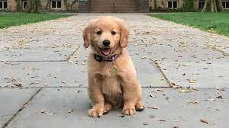
For example.,

Figure 5 – Sample input
- AIMS builder uses the output (detected objects in the image) of the ML layer
For example, For the above input image returns a dog which is used by the AIMS builder. AIMS builder uses a steganography algorithm to embed the detected objects into the input image.
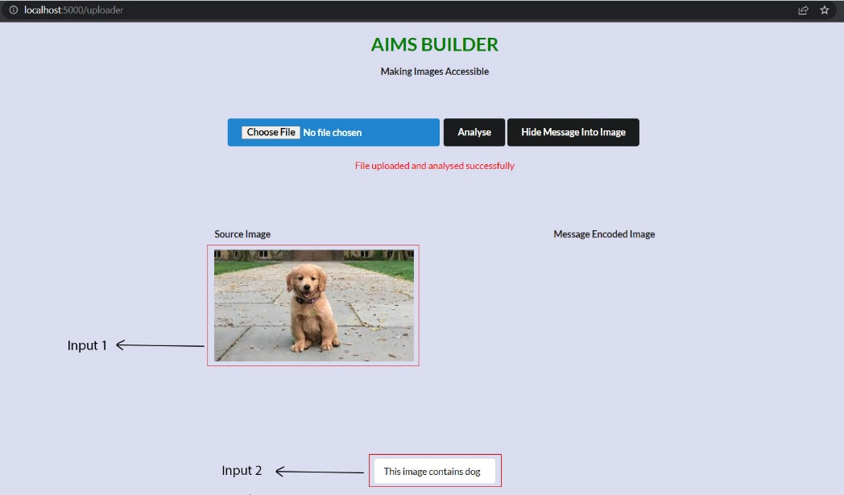

Figure 6 – AIMS builder user interface

AIMS EXTENSION
- AIMS extension takes the language as the input from the users.

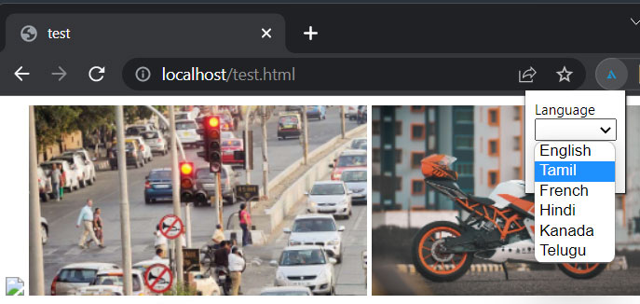
Figure 7 – AIMS extension user interface

- AIMS extension also uses the imagesrc (image URL) of the images present on the website as input.
For example, http://localhost/images/bikes.png
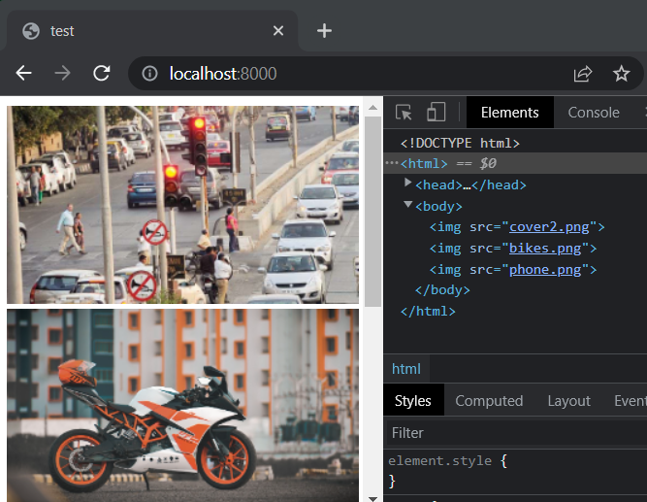

Figure 8 – Test site
- Translator module – which is the part of the browser extension that takes the message in one language as input and processes it.
For example, this image contains a motorcycle

CHAPTER 8
OUTPUTS
AIMS BUILDER
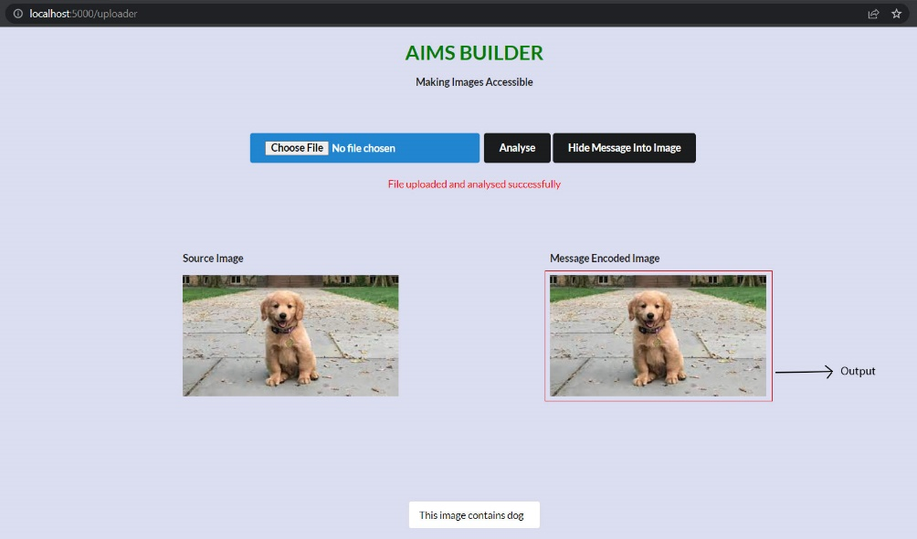
- On taking the plain image and image description as inputs, AIMS builder returns the message embedded image as outputs.

Figure 9 – Annotated image as output

- This output image can be used/included on the websites.
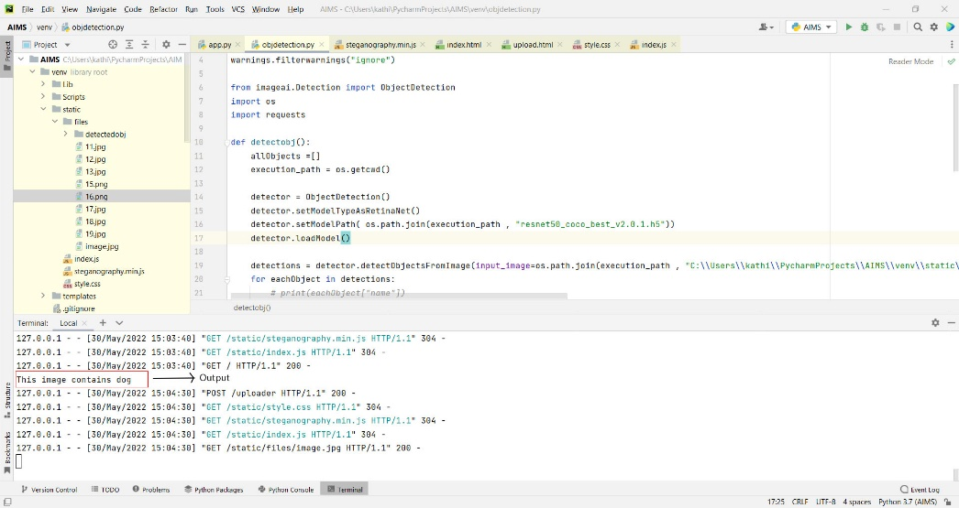
- The message description is generated automatically as output by the machine learning model.

Figure 10 – Performs object detection
AIMS EXTENSION
- AIMS extension extracts the embedded text in the images and returns the result as outputs.
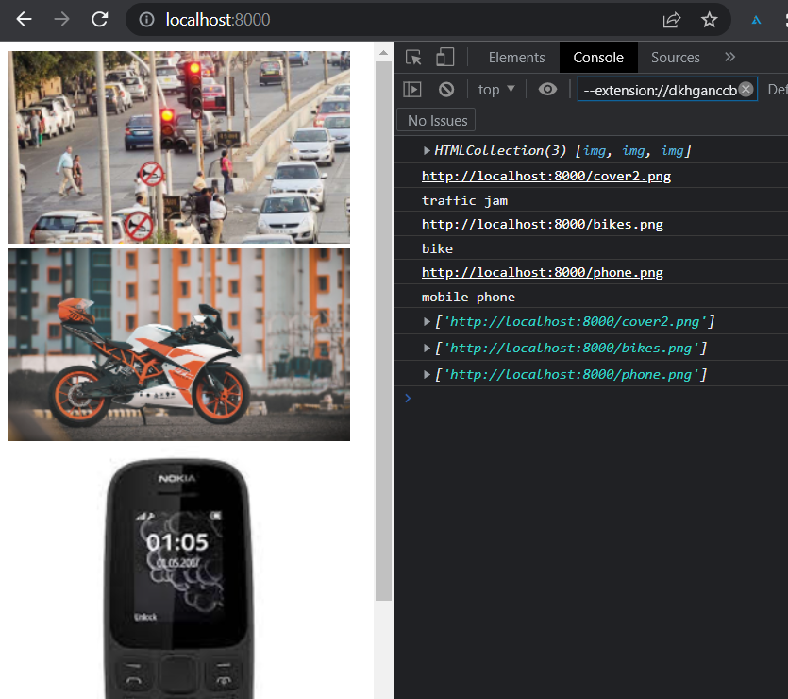

Figure 11 – AIMS extension in background

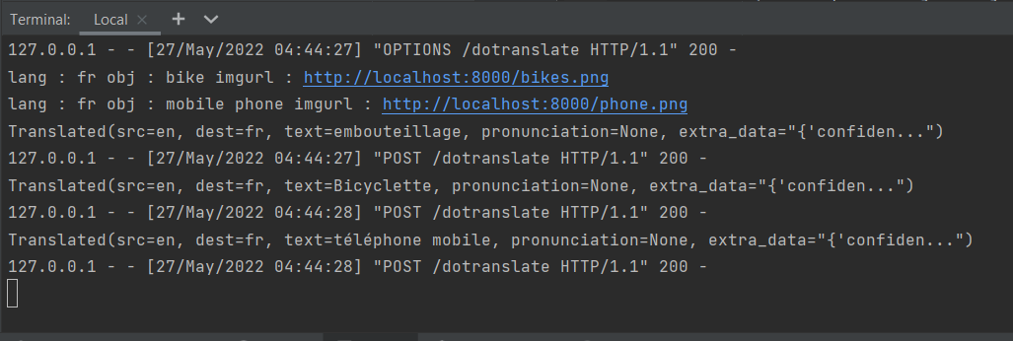
- Then the extracted messages are translated to the user’s preferred language

Figure 12 – Performs language translation

- This translated message description is updated in the alt attribute of the img tag which can be read by screen readers.
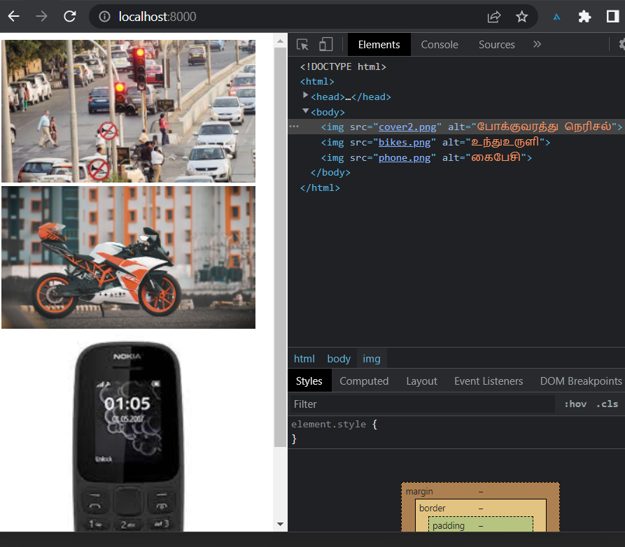

Figure 13 – Alt text updated

CHAPTER 9
ANALYSIS

AIMS ecosystem is built to assist the screen reader users to access the web content more easily by providing the alt attributes to the image tags. This system improves usability and makes the life of visually impaired users easy. On analysis, we found that our AIMS system describes the images before navigating to them and VI users are not forced to wait for the description for a long time. This system improved the overall usability and understandability of the given web pages by describing the images which were critical to understanding the content of the web page. For evaluation, we designed a website which contains 4-6 images and it is tested with our AIMS system, the overall time we need to wait for our AIMS extension to describe images is less than 4 seconds. AIMS extension extracts the message from the image, then perform translation as per the user preferences and sets the alternative text in the alt attributes of the img tag. The entire process is done at a higher speed to as not to make the user force wait for the image description for a long time.

CHAPTER 10
CONCLUSION

In the modern world, the Internet is very popular and almost all the business operations are carried out through the internet only. In that particular, webpages are so common media they need to be designed in such a way that they can be accessed by all people of the world irrespective of their ability. Visually impaired persons access the computer as well as websites via screen readers only, but images present on the websites are acting barriers to them. To avoid that, developers need to follow the web accessibility standards and guidelines to make it accessible to all. Using alternative text to images is a good practice as well as it helps people with special needs. But on the other hand, it makes developers’ life harder, which can be eliminated by the AIMS design. The ML model is built in such a way that uses computer vision to identify the object’s detection and it can be embedded into an image using steganography methods. Then at the end-user (VI User) side, the alternate text is updated in the image as per the user’s preferred language. If the user is visiting the site in another language, screen readers read the website in the language the webpage renders. But alt text is only read in English which can be solved by our AIMS design. This multilingual support helps the VI user to surf the webpage without any hustle.

CHAPTER 11
FUTURE ENHANCEMENTS

In the current design of the AIMS ecosystem, we use the steganography algorithm to embed the alt message inside the image which can be extracted using the AIMS browser extension. This AIMS system is enhanced by making a browser extension fully automatic, which scraps all the image tag and send it to the ML model to get the image captions and update them in the alt attributes of image tags. This AIMS design is further improvised by implementing Natural language processing (NLP) where the ML model itself identifies the content of the images based on the page context. This future design helps a lot of screen readers as well as saves a considerable amount of developers’ time.

CHAPTER 12
REFERENCES

[1] Ab Shaqoor Nengroo & K. S. Kuppusamy : Accessible images (AIMS): a model to build self-describing images for assisting screen reader users [2017]
[2] Md Rahman, Md. Mahib Hosen Ornob, et.al : An Effective Text Steganographic Scheme Based on Multilingual Approach for Secure Data Communication [2021]
[3] Nandhini Subramanian, Omar Elharrouss, et.al : Image Steganography: A Review of the Recent Advances [2021]
[4] Salwa Shakir Baawi, Dhamyaa AL-Nasrawi, et.al : Improvement of "Text Steganography Based on Unicode of Characters in Multilingual" by Custom Font with Special Properties Improvement of "Text Steganography Based on Unicode of Characters in Multilingual" by Custom Font with Special Properties [2020]
[5] Soheyle Amiran, Khaled Rasheed, et.al : Automatic Image and Video Caption Generation With Deep Learning: A Concise Review and Algorithmic Overlap [2020]
[6] Omkar Sargar, Shakti Kinger : Image Captioning Methods and Metrics [2021]
[7] Priyanka Malhotra, Ekansh Garg : Object Detection Techniques: A Comparison [2020]
[8] Sarathak Haldar : Design and Implementation of an Image Classifier using CNN [2019]
[9] Uran oh, Hwayeon Joh, et.al : Image Accessibility for Screen Reader Users: A Systematic Review and a Road Map [2021]
[10] Meredith Ringel Morris, Jazette Johnson, et.al : Rich Representations of Visual Content for Screen Reader Users [2018]
[11] Dae-Jea Cho : A Study on Web Accessibility Improvement Using Alternative Text Watermarking [2017]
[12] Park, E., Lim, H.: A study on providing alternative text of image for web accessibility improvement. Int. J. Appl. Eng. Res. 11(2), 762–765 (2016)
[13] Pennsylvania State University: Image alt tag tips for html. http://accessibility.psu.edu/images/imageshtml/ (2016)
[14] Fang, H., Gupta, S., Iandola, F., Srivastava, R.K., Deng, L., Dollár,P., Gao, J., He, X., Mitchell, M., Platt, J.C., et al.: From captions to visual concepts and back. In: Proceedings of the IEEE Conference on Computer Vision and Pattern Recognition, pp.1473–1482 (2015)
[15] Steve, F.: Html5: Techniques for providing useful text alternatives. Htt1ps://www.w3.org/TR/2011/WD-html-alt-techniques-20110113/ (2017)
[16] Park, E., Lim, H.: A study on improvement of evaluation method on web accessibility automatic evaluation tool’s <img> alternative texts based on OCR (2015)
[17] Eggert, E., Abou-Zahra, S.: Images concepts. https://www.w3.org/WAI/tutorials/images/tips/ (2015)
[18] Hamid, N., Yahya, A., Ahmad, R.B., Al-Qershi, O.M.: Image steganography techniques: an overview. Int. J. Comput. Sci. Secur.6(3), 168–187 (2012)
[19] Python documentation: https://docs.python.org/3/tutorial/index.html
[20] JavaScript documentation: https://www.w3schools.com/js/DEFAULT.asp
[22] Python Flask Documentation: https://flask.palletsprojects.com/
[23] Image AI Documentation: https://imageai.readthedocs.io/en/latest/
[24] Tensorflow documentation: https://www.tensorflow.org/tutorials
[25] Chrome extension manifest V2 documentation: https://developer.chrome.com/docs/extensions/mv2/
[26] Googletrans documentation: https://py-googletrans.readthedocs.io/en/latest/

